**LIFECHOICES CODING ACADEMY**

**OOP CHALLENGE**

|  |  |  |
| --- | --- | --- |
| **MODULE** | **OUTCOMES** | **DESCRIPTION** |
| 7 | 1-5 | **Object Oriented Programming** |

|  |  |  |  |  |  |  |  |
| --- | --- | --- | --- | --- | --- | --- | --- |
| **EXAMINER** | | GP DZVAPAPATSVA | | | **MODERATOR** | T TSOTETSI | |
| **DATE** |  | | **DURATION** | 4 Hours | | **TOTAL MARKS** | 25 |

|  |  |
| --- | --- |
| **SUBJECT:** | **PYTHON PROGRAMMING** |
| **TIME ALLOCATION:** | **4 HOURS** |
| **EXAMINER:** | **GP DZVAPATSVA** |
| **MODERATOR:** | **T TSOTETSI** |

**INSTRUCTIONS AND INFORMATION**

|  |  |  |  |
| --- | --- | --- | --- |
| 1.  2. | Answer ALL the questions.  Read ALL the questions carefully. |  |  |

**TASK**

Design a program that will implement the concept of inheritance using the given super class and subclasses. You are required to design a user interface similar to for the program in python using tkinter

BELOW IS THE CLASS DIAGRAM FOR QUESTION 1

|  |  |  |
| --- | --- | --- |
|  | Sick |  |
|  | -MSickID:String  -MDurationOfTreatment:Integer  -MDoctorsID:String |  |
|  | TreatmentAmount() |  |
|  |  |  |
| Influenza |  | Cancer |
| -ConsultationFee:Decimal |  | -ScanFee:Decimal |

* 1. Design the user interface as the one below. (10)
  2. Add comments to all sections of the program as you progress. (2)
  3. Identify the superclass and do the coding. Declare fclasses, constructors, methods. (10)
  4. Do the coding for the *Cancer* class and take the following information into consideration:

Medication for Cancer is fixed at R400.

Cancer patients pay a Scan Fee.

If the radio button for *Cancer* is checked, the user enters the Scan Fee in the *txtConsultation* text box. If the Scan Fee is greater than R600, a message must be displayed *Sorry we cannot treat you.* If the Scan Fee is less than R600, do the following calculation:

AmountPaidForTreatment = Medication + Scan Fee

AmountPaidForTreatment must be displayed in the label. (11)

* 1. BELOW IS AN EXAMPLE OF WHAT THE SCREEN MAY LOOK LIKE (USE THE SAME INFORMATION AS GIVEN BELOW BUT YOU ARE FREE TO ADD ADDITIONAL DESIGNS AS EVIDENCE OF MASTERY OF TKINTER MODULE)

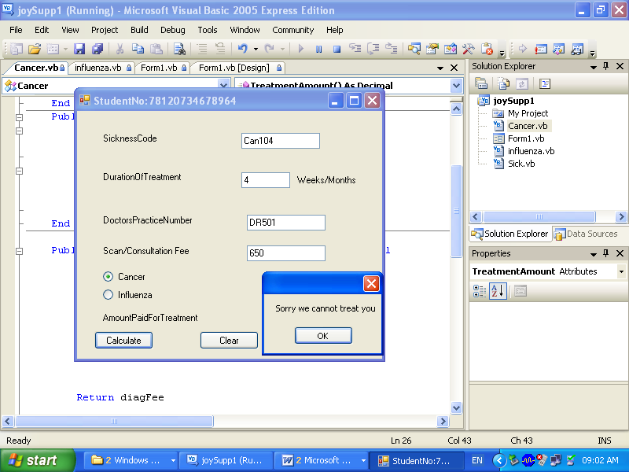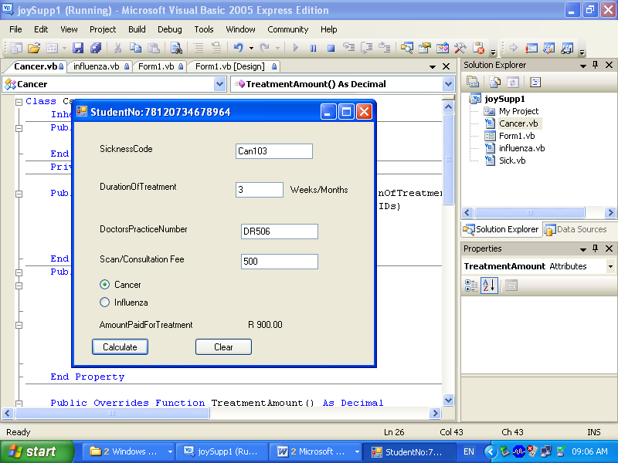

Do the coding for the *Influenza* class and take the following information into consideration:

Medication for Influenza is fixed at R350.50.

Influenza patients pay a Consultation Fee.

If the radio button for *Influenza* is checked, the user enters the Consultation Fee in the *txtConsultation* text box. If the Consultation Fee is greater than R600, the user gets 2% discount on the Consultation Fee. If the Consultation Fee is less than R600, the user gets No discount.

Do the following calculation:

AmountPaidForTreatment = Medication + Consultation Fee

AmountPaidForTreatment should be displayed in the label. (11)

* 1. BELOW IS AN EXAMPLE OF WHAT THE SCREEN SHOTS SHOULD LOOK LIKE (USE THE SAME INFORMATION AS GIVEN BELOW)

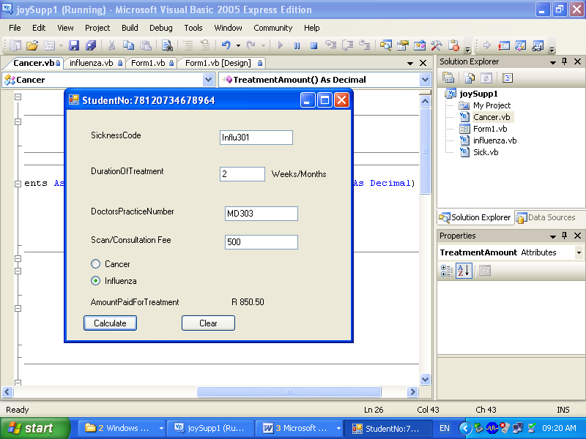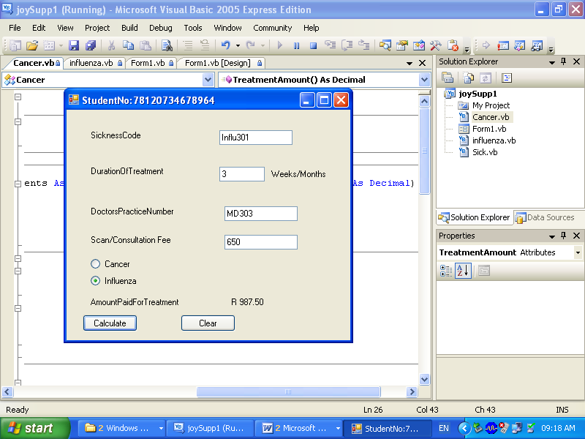

Code the Calculate button . (6)

1.6 Package your programe to an executable one for distribution (1)

**[50]**